Social Networks
2026

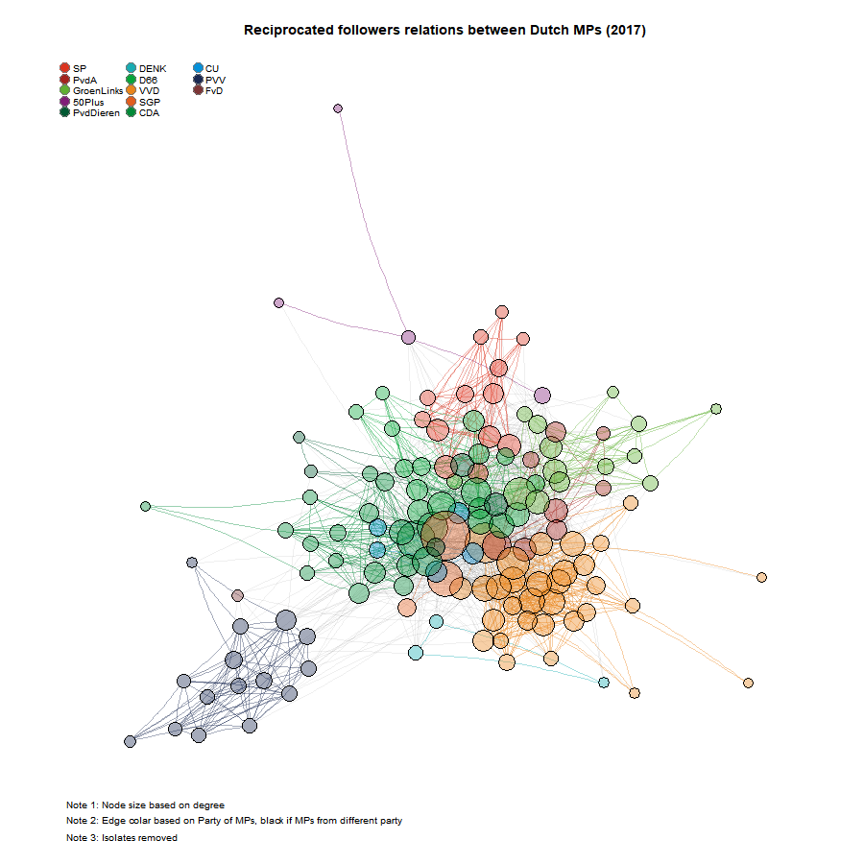

How to reach me?
Jochem Tolsma
Jochem.tolsma@ru.nl
MM.02.024
+31(0)625771448 (prefer signal, work number)
Course content
The course ‘Social Networks’ is part of the second year of the RMSCS. Students of other programmes may choose this course as elective but only after having successfully completed ‘Multilevel Regression Analysis’ and ‘Panel Regression Analysis’, or related statistical courses at the master’s level. The course will be taught in English. We will make us of the software package R. Some basic knowledge of R is recommended.
One of the key questions in social science research is how and with whom we interact and how such interactions within society or communities influence our own attitudes and behaviors. This course about social networks is therefore at the foundation of social science.
This course concerns:
- the development of social networks (with whom do we interact and why?);
- the consequences of such social networks (how do these interactions influence our behavior?);
- how both network formation and its consequences relate more generally to social inequality, cohesion and segregation.

This course starts out at the most basic network level and then gradually increases its complexity. We will start our discussion with the simplest social network, namely a dyadic relationship. We then move to egocentric networks. But the focus in this course lies on complete and dynamic social networks.

How can we describe the size, composition, structure and stability of social networks? What important network properties do they have? How do initial network properties influence the development of the network? We will demonstrate that longitudinal data of complete networks are very well-suited to disentangle selection versus influence mechanisms. That is, do birds of a feather flock together, or do birds become more alike over time?
There are many different methods to analyse social networks. In this course we focus on the Stochastic Actor Orientated Model as implemented in the R package RSiena. Mastering the basics of this method will hopefully provide a stepping stone for alternative methods like Exponential-family Random Graph Models.

Objectives
- See course aims: https://ru.osiris-student.nl/onderwijscatalogus/extern/cursus
- And see course content: https://snass.netlify.app/intro#aim

Prerequisites
- Advanced Statistics in R
- Statistic: Mixed-Effects Models

Teaching methods
- Lectures
- Workshops
- Assignments
- Discussions
- Presentations

This course follows a workshop format. This implies we will start early in the morning with a (short) lecture and presentations by students, but will spend the rest of the day to collectively work on lab assignments and/or our end project.

Together we will decide on the content of the lectures and presentations. And together we will determine the pace of the course. We make this course together.

During the course, students will work on their own Social Network Project. They will keep track of their lab work in a lab journal (i.e. within a git repository on Github) which is publicly accessible via a personalized website (i.e. github pages). They work on their project report within this repository.

For an examples see here:
Yeargroup 2022-2023
- https://anuschkap.github.io/labjournal/
- https://ninabranten.github.io/labjournal/
- https://daphnejanssen.github.io/labjournal/
Yeargroup 2024-2025
- https://fridaleertdingen.github.io/labjournal/
- https://koenlucas.github.io/labjournal/
- https://lucanbovens.github.io/labjournal/
- https://niels-vullings.github.io/labjournal/
- https://rajvanson.github.io/labjournalRVS/
- https://rolly-joger.github.io/labjournal/
- https://treesdude.github.io/labjournal/
Yeargroup 2025-2026
- https://github.com/bramkoeweiden/LJ_BramKoeweiden
- https://github.com/Chal-at-Ludicrous-Speed/ghislainelabjournal
- https://github.com/pkemper800/labjournal
- https://github.com/GroothuijsenTjeu/GroothuijsenTlabjournal
- https://github.com/HanneWolthuis/HWolthuis-labjournal
- https://github.com/mcmhusson/labjournal_mylene

Examination:
- Lab journal (pass / fail)
  - Including presentations (literature, network visualization)
- Project report (grade)
  - See Social networks evaluation form on Brightspace

Course schedule:
31 August
Week 1: Getting started
- SNASS (read before and/or after class): Chapter 1, Appendix A, Appendix B
- Lecture: Introduction Network Perspective
- Workshop: Setting up R, RStudio, Git, GitHub, Labjournal
- Lecture: Discussing final assignment
  - Descriptive research question (macro-level)
  - Explanatory research question on how networks evolve (micro-mechanisms)
- Workshop: R Tutorial
  - From SNASS
  - And/or here
- Workshop/Homework:
  - Formulate initial Descriptive and Explanatory Research Questions
  - Find two relevant papers with respect to your research questions and that clearly provide a social network perspective. At least one of the papers should use RSiena to answer (parts of) the research question.
  - Prepare presentation (10 min. max!!). Paper highlights; things you want to discuss, RQs.
  - Update your lab journal / website. Be prepared to show you lab journal during class. [include presentation, links to literature]

7 September
Week 2: Network description
- SNASS (read before class): Chapter 2, Paragraph 3.3, Chapter 4
- Student presentations on literature/RQ
- Lecture: Selection and Influence / Causes and Consequences
- Lecture: Descriptive statistics
- Workshop: Describing (complete) longitudinal network data
- Workshop/Homework:
  - Update your research questions
  - Start writing your introduction in which you discuss your RQs, the relevance of a social network perspective
  - Find one or two relevant papers with respect to your research question and focus on the type of data they use.
  - Make a list of the type of data you will need (actor attributes, relational attributes, etc.) in order to answer your RQs from a social network perspective.
  - Update your lab journal / website

14 September
Week 3: Webscraping network data / (using LLM for R-programming)?
- SNASS (read before class):
  - Chapter 8 (up to section 8.4)
  - Chapter 1
  - Chapter 2
  - Chapter 4 (up to 4.3.2.5)
  - Chapter 6 (I do not expect you to completely understand everything with respect to Moran’s I. But please have a first look yourself)
  - https://jochemtolsma.github.io/webscraping/index.html
- Lecture: introduction to webscraping
- Workshop/Demo: webscraping
  - Names of scholars
  - Publications of scholars
  - Profiles of scholars
  - Gender
  - Ethnicity
  - Gendered topics
  - OpenAlex
- Workshop/Homework:
  - Update your Research Questions
  - Construct your datasets (including your new variable/relation)
  - Describe your social network data (see week 2)
  - Be prepared to discuss the results of your descriptive statistics next week.
  - Start writing your data section and your result section
  - Update your lab journal / website

21 September
Week 4: Wrangling network data and network visualization
- SNASS (scan before class / read during class):
  - Chapter 9
- Literature (scan before class): https://ggraph.data-imaginist.com/index.html
- Workshop: network visualization (with iGraph and/or ggraph)
- Workshop/Homework:
  - Update your Research Questions
  - Visualize your social network data
    - Static
    - Interactive and/or dynamic
  - Be prepared to discuss the results of your network visualization next week.
  - Continue writing your data section and your result section
  - Update your lab journal / website

28 September
Week 5: RSiena (Introduction)
- Student presentations on network visualization
- SNASS:
  - Chapter 7 [in class!!]
  - See also: https://jochemtolsma.github.io/RSiena_tutorial/index.html
- RSiena manual: https://www.stats.ox.ac.uk/~snijders/siena/RSiena_Manual.pdf
  - Chapter 2
  - Chapter 5 (only the stuff about uniplex, one mode networks, and perhaps for nondirected networks)
- For dataset, see here: https://jochemtolsma.github.io/webscraping/45publicationsOpenAlex.html#22_input_data
- Lecture: Logic of RSiena
- Workshop: Basic RSiena models (structural component / selection)
- Workshop: RSiena models on own data
- Workshop / Homework
  - Be prepared to discuss next week (or week 7):
    - One or two complex network statistics
    - your intended modelling strategy,
    - your first RSiena results
    - Please send me a paper of SNA in practice you would like to see discussed next week.

5 October
Week 6: SNA in practice (and catching up)
- Lecture: Example 1 SNA in practice: ??
- Lecture: Example 2 SNA in practice: ??
- Workshop / Homework:
  - Updating lab journal
  - Working on final assignment

12 October
Week 7: RSiena (Advanced Topics) / Presentations
- Presentations:
  - Please give an update of your project (by students based on your lab journal / website / no ppt allowed)
  - What are the things you are going to work on the next couple of weeks?
- Workshop: RSiena: GOF
- Workshop: RSiena: Co-evolution of network and behavior
  - Behavior: gendered topics

Week 8-10
- Work on final project.
- Please email and schedule an appointment if you need help.

Literature:
- Academic Research articles: TBA
- Course handbook: Social Network Analysis for Social Scientists.
- RSiena manual
Recommended literature:
For all papers below, we have (or can have) access to the dataset.

Franken, R., Bekhuis, H., & Tolsma, J. (2023). Kudos make you run! How runners influence each other on the online social network Strava. Social Networks, 72, 151-164.
https://doi.org/10.1016/j.socnet.2022.10.001

Glatley, B., Rambaran, J.A., Sabree, K., Ryan, A., Walton, K., & Modey, C. (2025). Peer Relationships and Sense of Belonging in the Transition to College. Merrill-Palmer Quarterly 71(1), 34-62. https://dx.doi.org/10.1353/mpq.2025.a979035.

Kretschmer, D., & Leszczensky, L. (2026). Stable or dynamic? Explaining the development of Muslim and non-Muslim boys’ and girls’ friendship-making across adolescence. Social Networks, 84, 110-122.
https://doi.org/10.1016/j.socnet.2025.08.004

Tolsma, J., & Spierings, N. (2024). Twitter and divides in the Dutch parliament: social and political segregation in the following,@-mentions and retweets networks. Information, Communication & Society, 27(7), 1458-1477.
https://doi.org/10.1080/1369118X.2024.2305159

Time investment:

Total: 6EC = 6*28 = 168 hours

Week 1-7
7 workshops: 49 hours
Homework: 70 hours

Week 8-10
Finishing lab journal: 10 hours
Finishing project report: 32 hours
Publishing website: 7 hours

